**#Task 2**

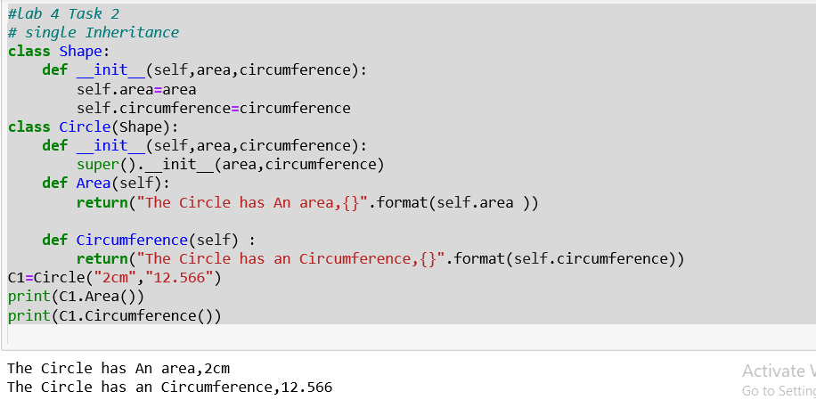

**#Task 4**

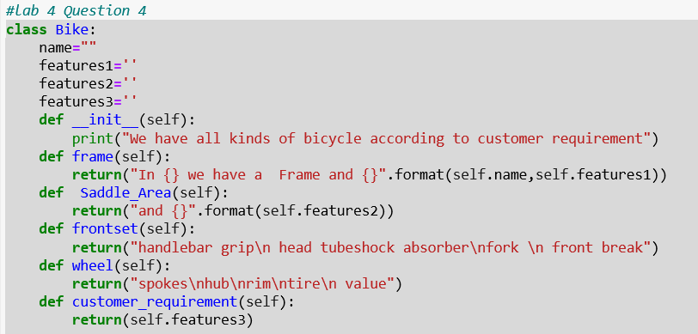

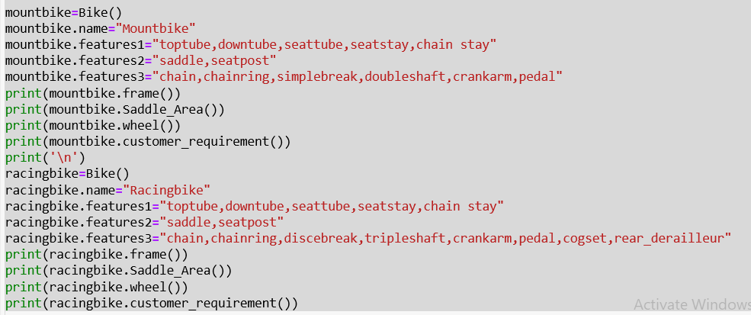

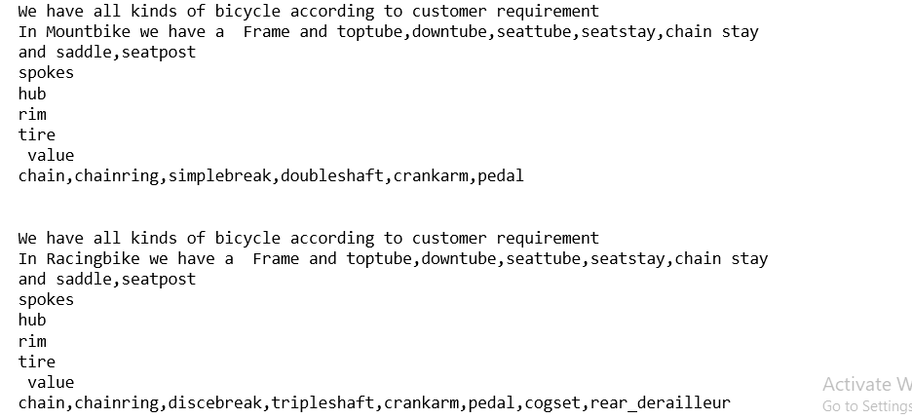

**#Task 3**

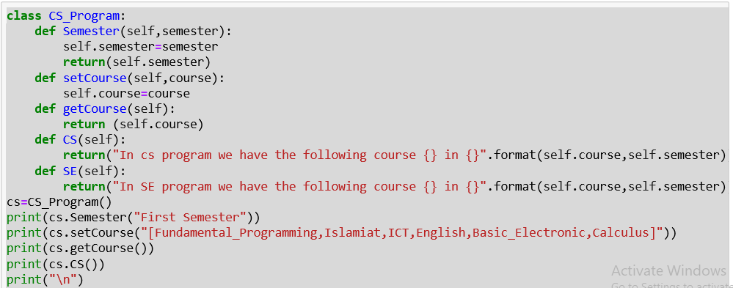

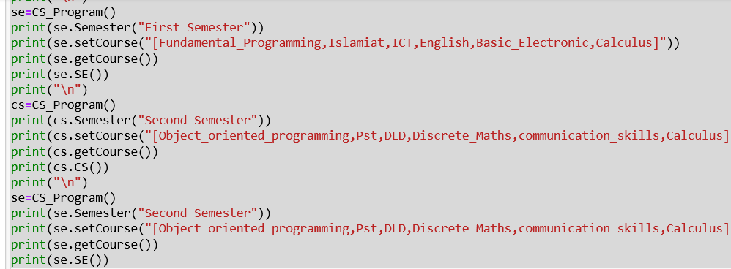

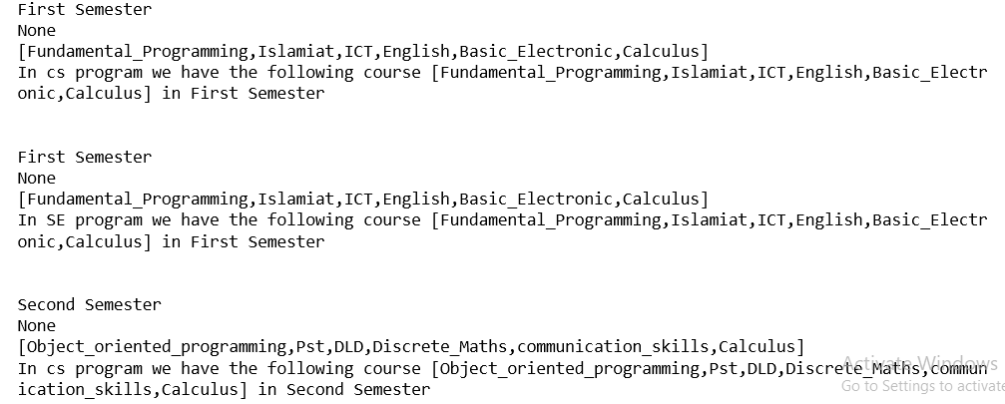

**#Task 1**

Class :

An object is any person, place, thing, concept, event, screen, or report applicable to your system.

Objects both know things (they have attributes) and they do things (they have methods).

A class is a representation of an object and, in many ways, it is simply a template from which objects are created. Classes form the main building blocks of an object-oriented application.

# Example

Although thousands of students attend the university, you would only model one class,

called Student, which would represent the entire collection of students.

Object :

An object in oops, is an abstract data type created by a developer. It **can** include multiple properties and methods and may even contain other **objects**. In most **programming** languages, **objects** are defined as classes. **object** provide a structured approach **to programming**